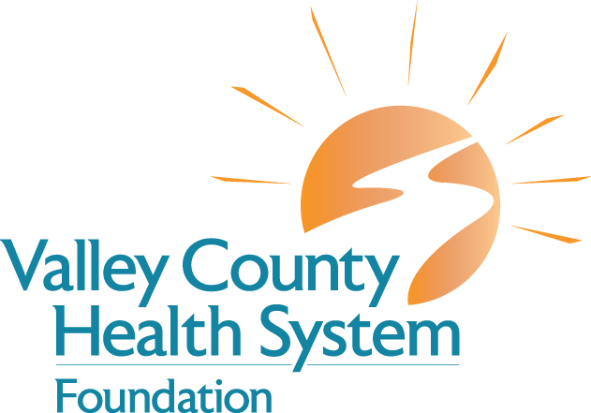

Your Gifts In Action

Your generous donations are an investment in the community, allowing us to continue ensuring high-quality healthcare, programs and services in Central Nebraska.﻿

2019

Home Health/Hospice – Variety of medical supplies, materials and literature

Emergency Services/Acute Care – Hamilton C2 Ventilator BiPap
VCHS Foundation Board Endowed Endowment Fund﻿

2018

Radiology – Philips Epiq 5G Ultrasound

Home Health/Hospice – Variety of medical supplies, materials and literature

Nutritional Services (Employee Mug Funds) – Ice/Water Dispenser

Human Resources – Stine Funding for recruitment
VCHS Foundation Board Endowed Endowment Fund﻿

﻿2017
Home Health/Hospice – Variety of medical supplies, materials and literature; landscaping & sprinklers

Human Resources – Stine Funding for recruitment

Surgery – Orthopedic equipment for shoulders and knees

Rehabilitation/PT – Treadmill

Acute Care - MP5 Monitor with CO2

Physician Recruitment Grant – Hallie Yantzie, APRN
VCHS Foundation Board Endowed Endowment Fund﻿

2016
Surgery - Neptune Vacuum Pump Kit
Stine Educational Loan – Tori Beran
VCHS Employees - Crisis Relief Funds
Home Health/Hospice – Blood Transport Systems, Electric Bed Rentals, Disposable Briefs, Ensure Nutrition Supplements, Home Health and Hospice Patient Orientation Booklets, Journey’s End Books, Respiratory DME Equipment, Chaplain Mileage
Radiology Department - Phillips Equipment 5 Update
Acute Care - Five Arjo-Century Overhead Lifts
VCHS Foundation Board Endowed Endowment Fund

2015
﻿Medical Clinic - Three Sandhills Canvas Prints
Home Health/Hospice - Final Gifts/Special Awarenees of the Dying Books, HH Patient Orientation Booklets, Disposable Briefs, Hospice Patient Orientation Booklets, Abby Press Hospice Pamphlets, Facing Your Fears about Dying DVD's, Patterson Medical/OT Equipment
VCHS Employee Mugs
VCHS Foundation Board Endowed Endowment Fund
Physician Recruitment Grant – Dr. Hillary Miller and Dr. Greg McClanahan
Stine Educational Loan – Tori Beran

2014

Home Health / Hospice - Supplies for Hospice Admissions, Flannel Hospital Blankets, Hospital Bed Sheets, Educational Supplies for Hospice Volunteers and Staff Education, Blood Pressure Cuffs, Music CD’s, Pulse Oximeters, CADD Pump Keys, Compassion Books, Bath Bench, Overbed Tables,Thermometers, Patient Orientation Booklets, Hospice Memory Cards, Journey’s End Booklets, Hopkins Baby Scale, and Digital Scale.﻿
Surgery - Venue 40 Anesthesia Ultrasound
Physical Therapy - Incline Trainer
Long Term Care - Canon Powershot Digital Camera﻿﻿﻿; Beauty Shop Chair; New Bedspreads; Bulletin Board; Sink for Beauty Shop; DVD/VCR
Acute Care/Specialty Clinic/Medical Clinic - 4 Prime TC Transport Chairs, 2 Prime X Electric 5thWheel Trauma Cart, 1 Prime Electric 5th Wheel Cart
Loup City Clinic - 15 X 20 Canvas Print from Sandhills Images﻿
Human Resources - Tablecloth with Logo
Ambulance - Video Laryngoscope
VCHS Foundation Board Endowed Endowment Fund

2013
Rehabilitation - Biodex Offset Unweighting System
Emergency Room - Zoll Power Infuser
Valley View Living Center - New Signage (made possible through VCHS Employee Donations)
Home Health/Hospice - Patient workbooks, lapel pins for military Hospice patients, Care Notes, Safe Presence Fall Defense System, Rug Mats for Community Foot Clinics, Items for Community Memorial Service, New Signage
(made possible through VCHS Employee Donations)
Building - Memorial Bench for Courtyard (In memory of Angie Dubas)﻿﻿
VCHS Foundation Board Endowed Endowment Fund

2012
Pharmacy/Nursing - One year online subscription to LexiComp
LTC - Fireworks for the 4th of July Celebration at VVLC (donated by Thad Meese)
Lab - Barcode Reader Upgrade for Urinalysis Machine
Home Health & Hospice - 15 Grief Support Books, "The Next Place", Portable CD Player, Funding for the Hospice Volunteer Banquet, and 4 Fingertip Pulse Oximeters, 3 Stethoscopes, & 2 Nursing Bags, Hospice Bed Sheets, Care Notes for Education, CADD pump (In memory of David Shoemaker)
Rehab - Four Pieces of Artwork (in memory of Marilyn M. Walker, donated by Steve Rounds, in memory of Mr. & Mrs. Downing Rounds & Leona Rounds)
Loup City Clinic Rehab - Artwork
Building - Decorative Water Fountain (in memory of Wendy O'Neel)
Valley View Living Center – Artwork (in memory of David Shoemaker, donated by Adam & Bethanne Kunz)﻿﻿
VCHS Foundation Board Endowed Endowment Fund﻿

2011
Long Term Care - Side Entry Tub
Surgery - Sterilizer Equipment
VCHS Foundation Board Endowed Endowment Fund
Home Health/Hospice - Digital Thermometers, Blood Transport Bags, Nursing Bags, Hospice Volunteer Booklets & Training Supplies
Rehab – Artwork (donated by Janene Welniak, in memory of Ed Hromas; Rollin & Mary Ann Struckman, in memory of Brad Struckman and Craig & Cindy Struckman, in memory of Frank "Doc" Dodds)
Mammography & Chemotherapy Treatment Room - Artwork (donated by the Arcadia Jr/Sr High Volleyball Teams)
VCHS Good Beginnings Program﻿﻿ - $1,000 donation﻿
2010
Emergency Room - Heart Monitor (Donated in part by the Erma Klanecky Estate)
Operating Room - Total Knee Replacement Surgical Equipment, Shoulder Surgical Equipment
Rehabilitation Services - Balancing Pads & Hand Weights
Chapel - Stained Glass (Boilesen Family Donation)
Ultrasound - Ergonomic Chair
Phlebotomy - 2 Reclining Chairs (one donated by Clem Klimek memorial funds)
Home Health/Hospice - Portable CD Player/CD's, Advance Directive Kits
VCHS Foundation Board Endowed Endowment Fund
2009
VCHS Foundation Board Endowed Endowment Fund
Education - Crash Mannequins
2008
VCHS Foundation Board Endowed Endowment Fund
Home Health/Hospice - Special wheelchair, three wheelchairs
Valley View Living Center - Nintendo Wii game system, Piano (In memory of Shirley Karre), Merlin Magnification machine
Nursing - Casualty Simulation Kit
2007
Cardiac Rehab - Two Treadmills, Nustep Machine, Pro II All-Body Ergometer Machine, Medical Rails and Mats
Home Health & Hospice - Room Furnishings and Décor on A-Wing
Nursery - Isolette

Valley County Health System Foundation wants to thank you

for your continued support & dedication!

